

**Project title:**

**Power Analyzer in MATLAB for Post Processing 3-phase-AC and DC Measurements with the Yokogawa DL750 ScopeCorder Oscilloscope**

**Barcelona, 8th June 2016**

TECHNICAL INFORMATION

|  |  |
| --- | --- |
| Authors: | Manuel Kersic |
| Revised by: | Oscar Gonzalez |

VERSIONS

|  |  |  |  |
| --- | --- | --- | --- |
| Number | Date | Action | Authors |
| 0 | 30.05.2016 | First draft version. | MK |
| 1 | 08.06.2016 | Small improvements in chapter 3. | MK |

# Contents

Contents ii

List of Figures iii

List of Tables iv

1 Introduction 1

2 Capabilities and Working Principle of the Measurement with Post Process 1

3 Measurement Procedure with the ScopeCorder 2

3.1 Objective of the Measurement 2

3.2 Needed Material 2

3.3 Preparation 2

3.4 Performing the Measurement 5

4 Power Analysis with Post Process in Matlab 8

4.1 Necessary Properties of Saved Data 8

4.2 How to Use the Script 8

4.3 Important Functions 11

5 Measuring and Plotting Transients 13

5.1 Performing the Measurement 13

5.2 Plotting the Transients 13

6 Comparison with the Fluke 435 Power Quality Analyzer 14

6.1 Measurement Setup 14

6.2 Results 15

6.3 Summary 23

7 Appendix 24

7.1 Formulas for Calculations 24

# List of Figures

Figure 1: Connection of Voltage Probe for Calibration 3

Figure 2: Screenshot 'File List' 4

Figure 3: Screenshot 'Save Menu Configurations' 4

Figure 4: Screenshot 'ACQ Menu Configurations' 6

Figure 5: Screenshot 'ACTION Menu Configurations' 6

Figure 6: Example of generated files from a successful measurement 7

Figure 7: Screenshot 'Scaling Correction' 9

Figure 8: Screenshot 'Channel Assignments' 9

Figure 9: Screenshot 'Select WVF Files' 9

Figure 10: Screenshot 'Plotbrowser with Power Analysis Plots' 10

Figure 11: Example for Plots of Transients: Sudden Supply Interruption at a Discharge of 10kW 13

Figure 12: Single Line Active Powers and Total Active Power, ScopeCorder 15

Figure 13: Single Line Active Powers and Total Active Power, Fluke 435 15

Figure 14: Single Line Reactive Powers and Total Reactive Power, ScopeCorder 16

Figure 15: Single Line Reactive Powers and Total Reactive Power, Fluke 435 (zoomed in) 16

Figure 16: Single Line Reactive Powers and Total Reactive Power, Fluke 435 (zoomed out) 17

Figure 17: Voltage and Current Waveforms at 13:16, ScopeCorder 17

Figure 18: RMS Values of Line Voltages (L-N), ScopeCorder 18

Figure 19: RMS Values of Line Voltages (L-N), Fluke 435 18

Figure 20: RMS Values of Line Currents, ScopeCorder 19

Figure 21: RMS Values of Line Currents, Fluke 435 19

Figure 22: Voltage and Current Harmonics on L1 (only during Charging Process), ScopeCorder 20

Figure 23: Voltage and Current Harmonics on L1 (only during Charging Process), Fluke 435 20

Figure 24: Formulas based on Power Electronics Script by Prof. Bernet, TU Dresden 25

# List of Tables

Table 1: Channel Assignments and Probe Connections 2

Table 2: Channel assignments for the post process 8

Table 3: Relation between Channel, Group and Trace 11

Table 4: Assignments of the FFT Matrix 11

Table 5: Assignments of the HARM50 Matrix 12

Table 6: Details on Fluke 435 Power Quality Analyzer 14

Table 7: Voltages and Currents compared at 13:16:00 21

Table 8: Active and Reactive Powers compared at 13:16:00 21

Table 9: Voltage and Current THD compared at 13:16:00 21

Table 10: Voltage and Current Harmonics on L1 compared at 13:16:00 22

Table 11: Voltage and Current Harmonics on L2 compared at 13:16:00 22

Table 12: Voltage and Current Harmonics on L3 compared at 13:16:00 23

# Introduction

The objective of this project was to being able to measure 3-phase-AC and DC voltages and currents simultaneously in order to obtain accurately the efficiency of power converters. Using the Yokogawa DL750 ScopeCorder was the best option available, because it was an oscilloscope with up to 16 channels and due to the waveform acquisition, it included the possibility to make further power quality analyses.

It resulted in the development of a measurement procedure and a Matlab script that is capable of calculating and plotting relevant values concerning the power quality out of the waveforms captured with the DL750 ScopeCorder.

So in this report, the measurement procedure and Matlab script is described in detail and in the end, a comparison with the Class A Fluke 435 Power Quality Analyzer is done in order to validate the results.

# Capabilities and Working Principle of the Measurement with Post Process

The script ‘YokogawaDL750PowerAnalyzer.m’ can realize a power analysis of simultaneous 3-phase-AC and DC voltages and currents measurements over short and long periods (hours or days). The power analysis consists of the calculations and plots of

* the efficiency of the power converter,
* the active AC and DC powers and the losses of the power converter,
* the reactive AC powers and power factors,
* the AC voltages and currents (rms values and waveforms),
* the DC voltage and current (rms values and waveforms),
* the trends of the harmonics and THD of the AC voltages and currents,
* the ripple factors of the DC voltage and current and
* the boxplots of the harmonics and THDs of the AC voltages and currents for a specified time interval.

If other values are needed, it is relatively easy to alter the script and functions in order to achieve the desired calculation and plotting.

The script uses the waveform measurements of the three AC line to neutral voltages and line currents and DC voltage and current. The single waveform acquisitions have typically a length of 0,2s, 0,5s or 1s. The script takes a set of these measurements, calculates out of the single waveform measurements the desired power quality values and can then plot them. As a result, the resolution of the power analysis plots depends on the time that lies between the single waveform acquisitions.

# Measurement Procedure with the ScopeCorder

## Objective of the Measurement

The task of this measurement process is to acquire sets of waveforms of several channels at the same time in order to perform a power analysis based on the waveform data. The power analysis should include information on the efficiency, active and reactive power, harmonics and ripple factors.

The following file formats were possibilities for saving the waveform data:

* ASCI: Saves data in a .csv file that contains the waveform vectors and a header with information on channel name, sample frequency, date and time of acquisition, … .
* Float: Saves data in a .fld file containing the waveform vectors in binary format, but without additional information
* Binary: Saves data in a .wvf file and a .hdr file, where the .wvf file contains the waveform vectors and time vectors in binary format. The .hdr file is the header file with information on channel name, sample frequency, date and time of acquisition, … .

The binary file format was the best option because it included all the information needed and could be easily read by a Matlab function that was provided by the ‘Physikalisch-Technische Bundesanstalt’ (see chapter 4.3 *Important Functions*).

For the saving method the Action-on-Trigger was chosen because it realized direct saving to the external storage device (USB stick or hard drive) during the waveform acquisition. Moreover, the acquisition mode is set to normal in order to acquire the waveforms without prior processing of the ScopeCorder. Alternative saving methods are for example the history memory function, the dual capture function and realtime recording. Other acquisition modes are averaging, envelope and box average mode.   
A good overview on the acquisition modes and saving methods can be found in the user’s manual of the DL750 ScopeCorder in chapter 2.4.

## Needed Material

* Yokogawa DL750 ScopeCorder
* 4 voltage probes, 3 for AC, 1 for DC (preferably the Pico TA057, as it showed more accurate results, see chapter 6 *Comparison with the Fluke 435 Power Quality Analyzer*)
* 3 AC current clamps (e.g. Chauvin Arnoux MN 60)
* 1 DC/AC current clamp (e.g. Chauvin Arnoux PAC 12)
* 1 USB stick or hard drive

## Preparation

***1. Connect probes to the ScopeCorder***

Connect the voltage probes and current clamps according to the table below:

|  |  |  |
| --- | --- | --- |
| Channel No. | Assignment | Probe to connect |
| 1 | UL1-N | Voltage probe |
| 2 | IL1 | AC current clamp |
| 3 | UL2-N | Voltage probe |
| 4 | IL2 | AC current clamp |
| 5 | UL3-N | Voltage probe |
| 6 | IL3 | AC current clamp |
| 7 | UDC | Voltage probe |
| 8 | IDC | DC/AC current clamp |

Table 1: Channel Assignments and Probe Connections

Make sure that all the voltage probes and the DC/AC current clamp are supplied with power and/or that the batteries are fully charged.

***2. Calibrate the voltage probes***

1. Turn on the ScopeCorder and connect one voltage probe with the test signal port and ground of the ScopeCorder like in the picture below:

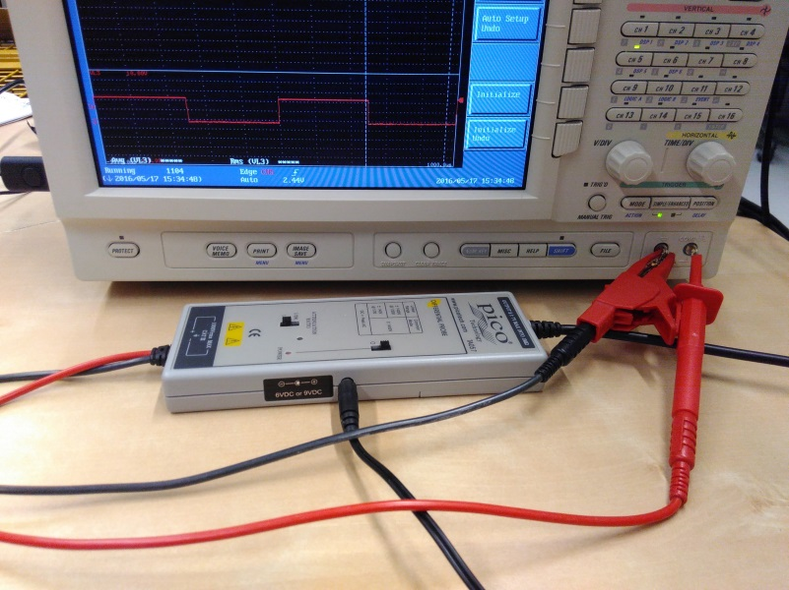

Figure 1: Connection of Voltage Probe for Calibration

1. Choose the most sensible scaling of the voltage probe
2. Run an Auto Setup by pressing “SETUP” -> “Auto Setup”
3. You should be able to see a pulse wave on the screen of the ScopeCorder with a period of 1ms, a duty cycle of 0,5 and an amplitude of 1V. If it is not the case, turn on the particular channel and zoom in with the turn knobs “V/DIV” and “TIME/DIV” until the signal is visible. Moreover, set “Coupling” to “DC”.
4. Actual calibration: Turn the adjustable small screw (or screws) on the probe until the signal doesn’t show an offset anymore and is perfect rectangular. If it is not possible to get a rectangular signal, the probe might filter some harmonics and shouldn’t be used for precise harmonic measurements.
5. Repeat steps a) to e) for all voltage probes
6. The voltage probes should stay with the channels they were calibrated with because the inner capacitances of the channels may vary from one another and a new calibration would be needed.

***3. Load the setup configuration***

1. Make sure the USB stick or hard drive you want to use is formatted as FAT. Then move the file “SETUP_ACDC.SET” from your computer to the storage device.
2. Turn on the ScopeCorder and connect the storage device with it by one of the two USB slots on the left side. Now load the setup-file by pressing “FILE” and specify “File Item” as “Setup”. Choose “Load” and go to “[USB2 ]” -> “SETUP_ACDC.SET”. Then “Load Exec (Setup)” and let the ScopeCorder load all 8 slots.
3. Exit the FILE menu by pressing “Esc” a few times. The screen should be split into three windows, the first containing VL1 and IL1, the second VL2, IL2 and VDC and the third VL3, IL3 and IDC.

***4. Prepare storage device and set saving properties***

Because the FAT file format has a limited number of files that can be stored in the main directory, one has to create subfolders where the files will be stored in. Otherwise, acquisitions over a long time period would stop when the limit of the number of files (512) is reached. In the subfolders however, the amount of data stored is only limited by the memory space of the storage device, not by the number of files.

1. Press FILE again and go to “Utility”. Navigate to “[USB2 ]”, so that you see “Path = USB2” in the second row of the gray dialog box
2. Press “Function” and then “Make Dir”. Then press “Dir Name” and choose a folder name. Then press “Enter”. The folder should be created in the USB2 Path.
3. Press FILE again. Then go to “File Item” and choose “Waveform”. Moreover, set “Date Type” to “Binary”. Now press “Save”
4. In the next menu go to “File List” and navigate to the folder you created in step b), so that you see “Path = USB2/<yourfoldername>”. Press ESC.

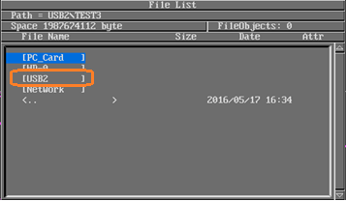

Figure 2: Screenshot 'File List'

1. Back in the Save menu choose “File Name”. Here you should set “Auto Naming” to “Numbering” and then choose a File Name according to the measurements you want to perform. Press ESC.
2. Back in the Save menu set “Trace” to “All” and “History” to “One”. Moreover “P-P Comp” should be off. In total it should look like that:

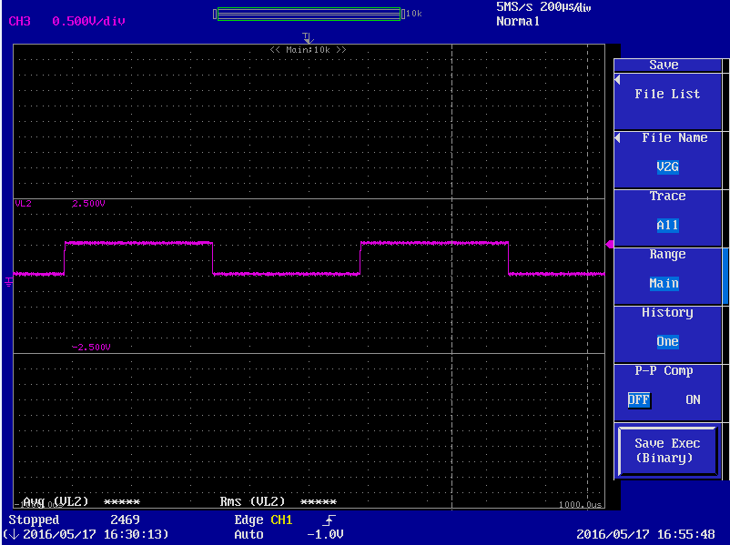

Figure 3: Screenshot 'Save Menu Configurations'

1. You can now exit the Save menu by pressing ESC two times.

## Performing the Measurement

***5. Connect probes to device to be measured***

1. Connect the probes to the device. Check if all probes are turned on and that the batteries are charged. With the DC/AC current clamp, turn off the Auto-off (Chauvin Arnoux PAC 12: press and hold “DC Zero” while turning on) and perform the offset correction (Chauvin Arnoux PAC 12: press “DC Zero” one time when you are sure that there is no current flowing through the clamp).
2. Estimate the voltages and currents you will measure and choose the right scaling of the probes
3. Choose the same probe scaling for each channel by pressing e.g. “CH 1” and there choose “Probe”. If the scaling of the probe is not available here, you will have to adjust the scaling later in the post process like described in “How to Use the Script” further above.
4. Make sure that all AC channels are set to “Coupling” “AC” and that all DC channels have a DC coupling.
5. Adjust the bandwidth for each channel depending on the frequencies or noise you want to filter.

***6. Start measurement***

|  |  |
| --- | --- |
| **Info:** | In this measurement process we only use three different trigger modes. In order to distinguish between them, one is simply called “***normal mode***”, one “***time mode***” and the other one “**manual mode**”. The normal mode will acquire the waveform as quick as possible, which would result in one waveform file (of the time length that you see on the ScopeCorder display) saved about every 5 seconds. The time mode will initiate the trigger on a set time interval, however the shortest interval is one minute. And the manual mode will allow you to initiate the trigger manually by pressing the “MANUAL TRIG” button.  To change between them go to “SIMPLE/ENHANCED” in the TRIGGER section. Here select “Simple” and choose your source. If “CH1” is set as the source, the trigger is in our terms in “normal mode”. If the source is set to “Time”, the trigger is in our “time mode” and you can choose the desired time interval. In order to set up the manual mode, set the time interval to 24h, so that the trigger will be initiated automatically only once every 24h. |

1. Make sure the trigger is in normal mode and that the LED over “START/STOP” is lit. If it is not lit press “START/STOP”.
2. Start the device you want to measure.
3. Have a look on the display of the ScopeCorder and check if all the signals are visible. Make sure that there are no values cut off or outside the borders of the scope. You might have to adjust that with the turn knob “V/DIV”.
4. By turning the knob “TIME/DIV” make sure that the x-axis scaling is set to at least 20ms/div, preferably it should be 20ms/div or 50ms/div. This is important for the harmonic analysis later, see *4.1 Necessary Properties of Saved Data.*
5. If everything is alright, press “START/STOP”, so that the waveforms on the scope don’t update anymore and that the LED above this button is turned off.
6. Press “ACQ” right next to “START/STOP” and make sure that it has the following settings:

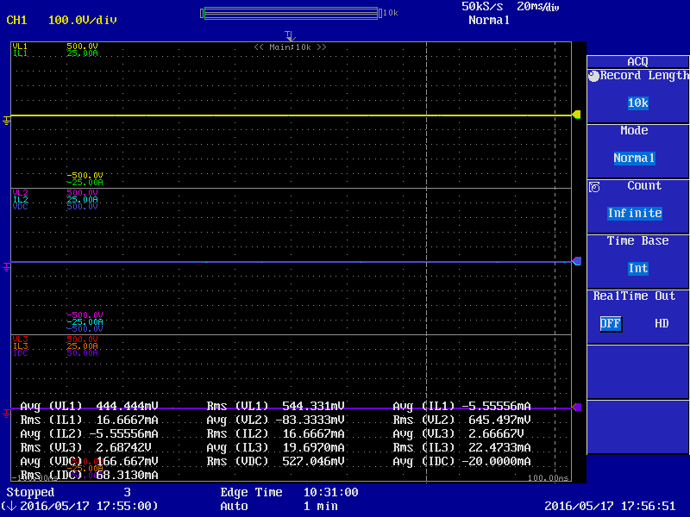

Figure 4: Screenshot 'ACQ Menu Configurations'

Info: *It is also possible to change the parameter “Record Length”. That would change the sample frequency, which one can see on the screen on the top right corner above “Normal”. In this configuration, it is set to 50kS/s, so a sample frequency of 50kHz. This means that we acquire 1000 samples per cycle (20ms), which is more than enough for the later harmonic analysis. By lowering this value, one can reduce the sizes of the saved files. The relationship between the Time Axis Setting, Sample Rate and Record Length can be found in the Appendix of the User’s Manual.*

1. Press “SHIFT” and then “MODE” (“ACTION”) in the TRIGGER area. Select “Mode” to be “On Trigger” Then go to “Action” and choose “Save to File”, “Binary”. The “Sequence” needs to be “Continue” and the “ACQ Count” should be set to “Infinite”. Compare with this configuration:

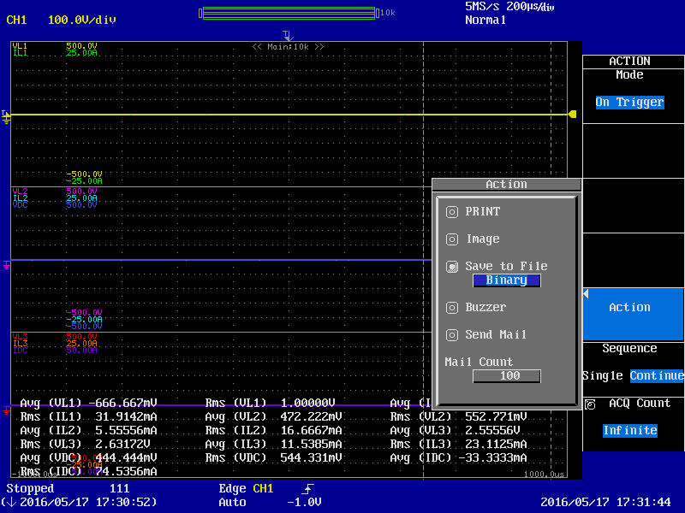

Figure 5: Screenshot 'ACTION Menu Configurations'

1. Depending on the time interval you want to acquire your waveforms, set the trigger to normal mode, time mode or manual mode (see blue info box above).
2. In order to making sure that the files will be saved correctly, it could be useful to check the saving and perform the steps 4 c) – f) again.
3. Press “START/STOP”. The measurement will be performed now and will be automatically saved in the subfolder on the USB stick. If the saving process is performed correctly, you will see a USB sign and a loading bar in the left top corner every time the trigger is initiated. The number and time of the waveform acquisition is displayed in the left bottom corner.
4. To finish the waveform acquisition press “START/STOP” again. You should see the message “Completed action-on-trigger.”
5. You can now disconnect the USB stick safely and transfer the files onto your PC and perform the post process as described in chapter 4 *Power Analysis with Post Process in Matlab*.
6. If you want to see the waveforms again normally on the scope, turn off the action on trigger again by going to the trigger action menu like in step g) and set the “Mode” to “Off”. Additionally make sure that the trigger is in the normal mode.
7. For another measurement, create a new subfolder on the storage device like described in step 4 and redo steps 6 a) – l).

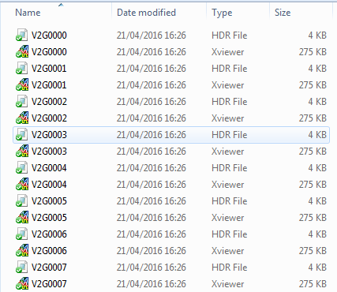

Figure 6: Example of generated files from a successful measurement

# Power Analysis with Post Process in Matlab

## Necessary Properties of Saved Data

The **channel assignments** should be the following:

|  |  |
| --- | --- |
| Channel 1: | UL1-N |
| Channel 2: | IL1 |
| Channel 3: | UL2-N |
| Channel 4: | IL2 |
| Channel 5: | UL3-N |
| Channel 6: | IL3 |
| Channel 7: | UDC |
| Channel 8: | IDC |

Table 2: Channel assignments for the post process

If this is not the case, one might have to change some assignments in the functions and script.

Moreover, one has to save the waveforms with the ***action on trigger*** and set ***save to file*** -> ***binary***. This will result in one .wvf-file and .hdr-file with the same name for each time the trigger is activated. The .wvf-files contain all the waveform information of the active channels and the .hdr-files are the headers with information on time, channel labels, sample frequency, etc.

Additionally, one has to set the acquisition time for one waveform to at least **200ms** (which are 10 cycles of a 50Hz signal) because the calculations of the harmonics require this time frame (according to IEEEStd519-2014). One can set this acquisition time by choosing the horizontal scale to be **20ms/div** (or more).

In general, it is useful to set the trigger activation to a fix time interval (by choosing the trigger source to be time). However, the minimal time interval is 1 min which would lead to a low resolution of data and is only recommended for long measuring periods (e.g. for power profiles of several hours or days). For shorter measuring periods, one should set the trigger to ***simple*** with the trigger source being CH1 for example. This will lead to time intervals of ≈5s (as this is the time the ScopeCorder needs to save the waveform on the USB stick or hard drive).

The detailed descriptions on the configuration of the oscilloscope and the measurement procedure can be found in the chapter 3 *Measurement Procedure with the ScopeCorder*.

## How to Use the Script

All the functions described in chapter 4.3 *Important Functions* have to be in the same folder like the script, so that it is possible to execute the script.

The script is divided into 4 sections and they should not be executed all at once, but rather sequentially by pressing Ctrl + Enter. The quick functional process is the following:

1. Before running the script itself, open the function **wvfcalcvalues.m** and scroll down to the #scaling correction part, just before CALCULATIONS:

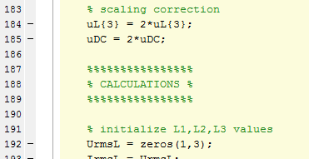

Figure 7: Screenshot 'Scaling Correction'

Here you can define the scaling correction, in case that the probes you use have scaling that you cannot set in the ScopeCorder. In the example above, the values for uL3-N (uL{3}) and uDC (uDC) are doubled because the Pico Differential Probe TA057 was used with a scaling of 1/200, whereas the ScopeCorder could only be set to 1/100.

(In case you couldn’t use the channel assignments described in the chapter before, you can define them differently in the section #reading .wvf and .hdr:

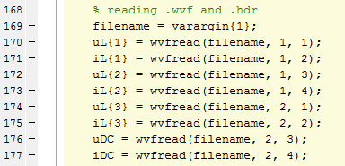

Figure 8: Screenshot 'Channel Assignments'

Go to chapter 4.3 *Important Functions* and read about the wvfread function for further information.)

1. Run **Section 1**, browse to the folder with the .wvf and .hdr files in the dialog box that will pop up and select all the files, you want to process:

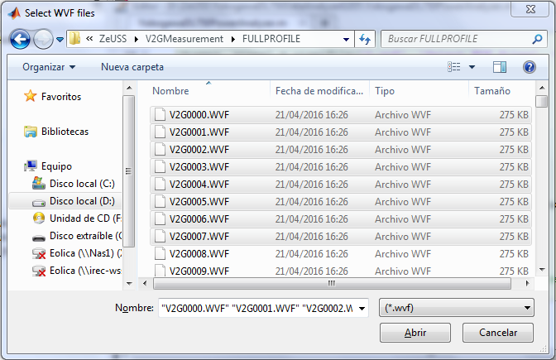

Figure 9: Screenshot 'Select WVF Files'

This will calculate the values and save them in the folder of the .wvf and .hdr files as a .mat-file, so that you only have to execute this section one time for a set of files. The next time you want to plot the power analysis, just open this .mat-file, skip step 1 and go on directly with step 2.

1. Run **Section 2a**. The plots of the power analysis will pop up in the plotbrowser:

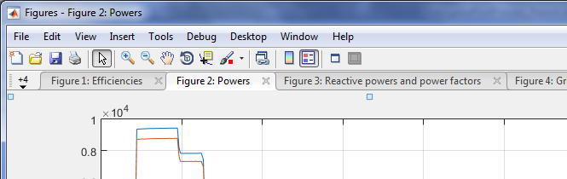

Figure 10: Screenshot 'Plotbrowser with Power Analysis Plots'

1. For a harmonic analysis of a specific time period, go to one of the figures from step 2 and zoom into the area you want to analyze. Now go back to the script and execute **Section 2b**. In the dialog box, the time limits of your current figure will be proposed (you can also adjust them manually). You only have to choose which line you want to analyze. In the plotbrowser the boxplots of voltage and current harmonics of the selected time period will show up.
2. If you want to see the waveforms for one time instant, go to one of the figures from step 2 and choose the desired point with the data cursor. Then right click and ‘Export Cursor Data to Workspace…’. Keep the default variable name ‘cursor_info’. Now execute **Section 3.** In the plotbrowser the plots ‘AC voltages’, ‘AC currents’ and ‘DC’ will show up.

For further understanding, the sections are described here in more detail:

**Section 1** calculates all the values needed for the plotting and loads them into workspace variables, so that they can be processed in the next sections. When executing, first a dialog window in which one can choose the files one wants to analyze, is opened. The files don’t have to be in the current folder. Then a loop operation is started that calculates all the values defined in the function ‘wvfcalcvalues’ (see chapter 4.3 *Important Functions* or 7.1 *Formulas for Calculations*) for all the selected files in the dialog box. These values are then written into the array ‘X’. The section also generates the cell array ‘Xread’, which is nothing more than ‘X’ combined with the names of the calculated values (from the cell array ‘header’), which makes it possible to read the calculated values like a tabular when opening ‘Xread’ from the workspace. In the end of the section, the important variables ‘X’, ‘Xread’, ‘header’, ‘pname’ and ‘fnames’ (for knowing which files and where they are stored) are saved as a .mat-file in the folder of the selected .wvf-files with the name ‘<firstfilename>-<lastfilename>.mat’.

Additional information: If you want to change the values that are calculated, you have to open the function ‘wvfcalcvalues’ and change the formulas in the calculations section. Then scroll down to the values matrix and write into the list, which variables should be given out. At the top of the function, the header cell is defined, where you then have to list the names of the variables you defined in the matrix ‘values’. The number of elements in ‘header’ and ‘values’ has to be the same. Save the function, go back to the Matlab script and execute section 1. You can then see the calculated values as a table when you open the workspace variable ‘Xread’. However, you won’t be able to execute the sections 2a and 2b normally anymore, when you changed the calculated values.

**Section 2a** realizes the desired plots for the power analysis from the data stored in ‘X’ and ‘header’. The commands for all the plots are very similar: The column indices for the values that should be plotted are defined in a variable ‘i_...’. The next commands then generate the figure and get the values for the plots from ‘X’ and the names from ‘header’ using the indices in ‘i_...’. So it is actually really easy to generate a new plot: Just copy one of the command blocks and define your own desired values to plot by their indices in ‘i_...’. This might be necessary if you changed the calculated values (see above).

**Section 2b** gives you the possibility to analyze the statistics of voltage and current harmonics in form of a boxplot for a specified time period. An input dialog box will open, in which one can specify the time period and the line (1, 2 or 3) one wants to analyze. The default values for the start and end times are taken from the x axis time limits of the current figure, so it is useful to operate like described in step 3 above.

**Section 3** plots the waveforms of AC voltages and currents and DC voltage and current of one .wvf and .hdr file. It is just executing the function ‘wvfplotwave’ (see chapter 4.3 *Important Functions*) with the input being the path and filename with the index of the cursor_info. So one has to operate like in step 4. Moreover, it is important that the .wvf and .hdr files mustn’t change their saving location after having executed section 1, because then the variables ‘pname’ and ‘fnames’ would point to the old saving location and it won’t be possible to execute this section.

## Important Functions

**wvfread:** y = wvfread(filename, Group, Trace)

[y,t] = wvfread(filename, Group, Trace)

It is a function that was freely available on the internet from the ‘Physikalisch-Technische Bundesanstalt’. It can read a .wvf-file and gives out the waveform vector y (and time vector t if needed).

Group and Trace are variables that indicate the channel number and are generated from the oscilloscope after saving. The assignments are the following:

|  |  |  |
| --- | --- | --- |
| Channel | Group | Trace |
| 1 | 1 | 1 |
| 2 | 1 | 2 |
| 3 | 1 | 3 |
| 4 | 1 | 4 |
| 5 | 2 | 1 |
| 6 | 2 | 2 |
| 7 | 2 | 3 |
| 8 | 2 | 4 |

Table 3: Relation between Channel, Group and Trace

It needs the function wvfreadb in the same folder in order to function.

**hdrread:** info = hdrread(filename)

This function was also freely available from the ‘Physikalisch-Technische Bundesanstalt’. It can read the .hdr-file and loads its information into the struct variable info in the workspace. In the post processing, it is used to extract the information on the time of the waveform acquisition and the sample frequency.

**dftgeneral:** FFTmatrix = dftgeneral(waveformvector, Fs)

This function executes a discrete Fourier transformation out of a waveformvector with known sample frequency Fs. The output FFTmatrix is an array with the following assignment:

|  |  |
| --- | --- |
| Row 1 | Frequencies (Hz) |
| Row 2 | Amplitudes (Unit of the signal) |
| Row 3 | Angles (º) |

Table 4: Assignments of the FFT Matrix

**harm50:** HARM50 = harm50(FFTmatrix)

This function calculates the harmonics from FFTmatrix (which is obtained with the dftgeneral function) in accordance with IEEE Std 519-2014. It assumes that the fundamental frequency is 50Hz. The frequency stepsize of the FFT matrix needs to be 5 Hz, which will be accomplished by a measurement over 200 ms (10 cycles) and/or by choosing the right number of points from the waveformvector. HARM50 is an array which has the following assignment:

|  |  |
| --- | --- |
| Row 1 | Frequencies of harmonics (Hz) |
| Row 2 | RMS values of harmonics(Unit of the signal) |
| Row 3 | Proportions of harmonics to fundamental (%) |
| Row 4 | Phases of harmonics(º) |

Table 5: Assignments of the HARM50 Matrix

The column indices indicate the orders of the harmonics.

The phases are calculated for cosine and are shifted so that the phase of the fundamental is 0.

**wvfcalcvalues:** values = wvfcalcvalues(filename)

header = wvfcalcvalues(‘header’)

This function is the key of the post processing script. It calculates the desired values out of one pair of binary files (one .wvf-file and .hdr-file with the same name) and uses all the functions described above for doing so. If the input argument is ‘header’, the output is a 1-dimensional cell-array containing all the names of the values that this function calculates. If the input argument is a filename (with path, if the file is not in the current folder), it calculates values which is a horizontal vector with the same column indices as the header cell-array. The calculated values are the following:

* efficiency
* AC active, reactive and apparent power and DC power and active power losses
* cos(φ) and power factor
* rms values of AC voltages and currents
* averaged values of DC voltage and current
* THD of the AC voltages and all the proportional harmonics up to order 20
* THD of the AC currents and all the proportional harmonics up to order 20
* ripple factors of DC voltage and current

The formulas used for the calculations are listed in chapter 7.1 *Formulas for Calculations* and can of course be viewed by reading the function code.

**wvfplotwave:** wvfplotwave(filename)

This function opens 3 figures with the plots of the 3-phase AC-voltages, 3-phase AC-currents and the DC voltage and current. One just has to enter the filename as a string (or with the corresponding path, if the file is not in the current folder).

# Measuring and Plotting Transients

After having created the Matlab script and measurement process for the power analyzation, there was the need to analyze as well the transients on the DC side of the EV charger. With some little changes, this is easy to perform with the knowledge described in the previous chapters.

## Performing the Measurement

Basically you should proceed like described in chapter 3 *Measurement Procedure with the ScopeCorder*. There are only two differences you should take into account:

* Set the time for the acquisition higher (e.g. set *time/div* to 2s, which results in an acquisition of 20s per saved file). You have to apply this change at step 6 d).
* Set the trigger mode to ‘manual’ as defined in the blue info box in step 6. This change has to be applied at step 6 h).

Every time you want to acquire the transient behavior, just press the button ‘MANUAL TRIG’ and the ScopeCorder will save the run of the curves.

## Plotting the Transients

To obtain the plots, simply execute the script ‘plottransients.m’. In the dialog box that pops up, choose the desired .wvf file and you will see a figure containing the AC currents, DC voltage and DC current. See the example below.



Figure 11: Example for Plots of Transients: Sudden Supply Interruption at a Discharge of 10kW

# Comparison with the Fluke 435 Power Quality Analyzer

## Measurement Setup

In order to evaluate the accuracy of the power analysis with the Yokogawa ScopeCorder, a simultaneous measurement with the Fluke 435 Power Quality Analyzer was carried out. Some details about this measuring instrument are listed below:

|  |  |
| --- | --- |
| Device | Fluke 435 Power Quality Analyzer  foto-fluke.png |
| Measurement methods used | IEC 61000-4-30 |
| Measurement performance | Class A (IEC61000-4-30) |
| Power quality | EN 50160 |
| Harmonics | IEC 61000-4-7 |
| Set averaging time | 500 ms |

Table 6: Details on Fluke 435 Power Quality Analyzer

The measurements performed with this device should be reliable, as it has a measurement performance rating of Class A.

The voltages are measured directly and the currents are measured with Chauvin Arnoux MN60 current clamps (set to 20A range).

The Yokogawa DL750 ScopeCorder oscilloscope acquired the voltage with the Yokogawa differential probe 700924 on L1 and L2 and with the pico differential probe TA057 on L3. The current was measured for all three lines with Chauvin Arnoux MN60 current clamps, like the Fluke 435.

The ScopeCorder and the Fluke 435 measured simultaneously the charging process of a Nissan Leaf electric vehicle. The V2G charger from Magnum Cap was set to a charging power of 10kW.

## Results

The figures below give an overviewing comparison between the two measuring instruments. The time difference of ≈20s should be noted. A more precise comparison can be found in the tables further below.



Figure 12: Single Line Active Powers and Total Active Power, ScopeCorder

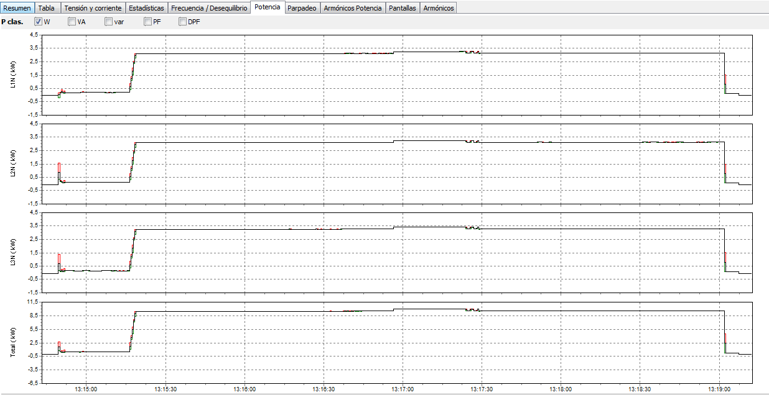

Figure 13: Single Line Active Powers and Total Active Power, Fluke 435



Figure 14: Single Line Reactive Powers and Total Reactive Power, ScopeCorder

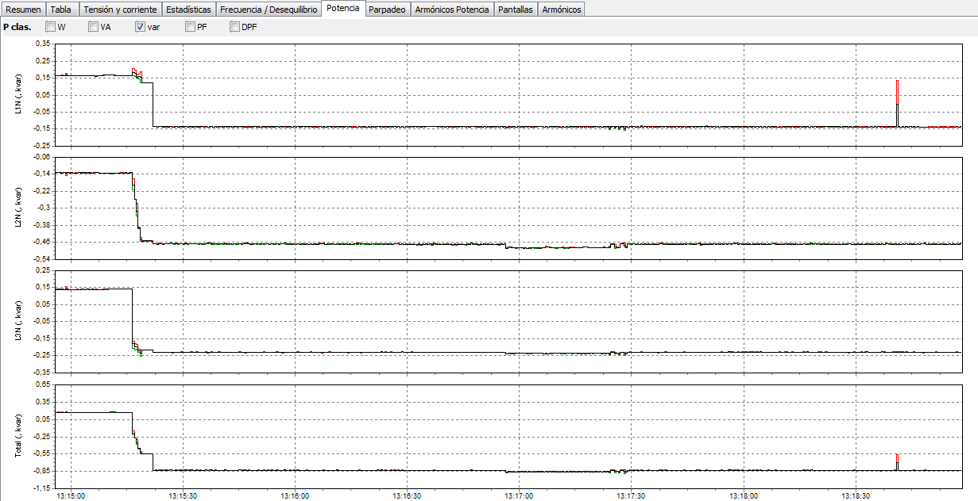

Figure 15: Single Line Reactive Powers and Total Reactive Power, Fluke 435 (zoomed in)

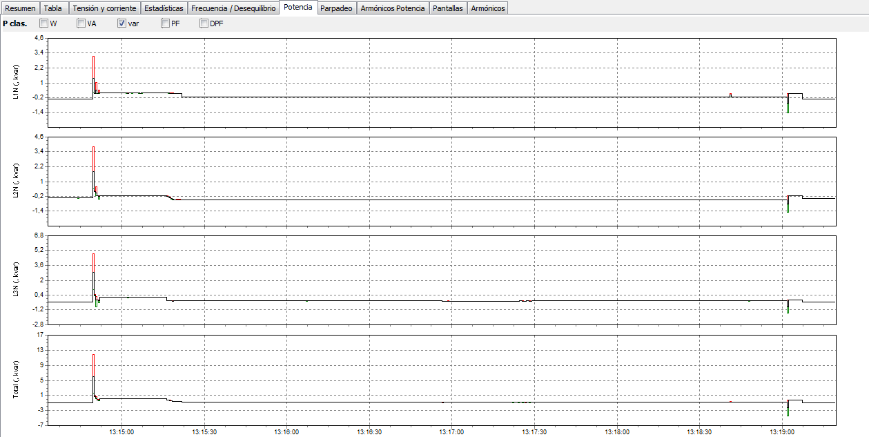

Figure 16: Single Line Reactive Powers and Total Reactive Power, Fluke 435 (zoomed out)



Figure 17: Voltage and Current Waveforms at 13:16, ScopeCorder

Considering the reactive powers, one can see some differences between the two measurement instruments: When reaching the steady state of the charging process (at ≈13:16) the ScopeCorder measures a reactive power in L1 that is very different from the Fluke 435 measurement and from the other two lines. The other two lines however coincide quite well with the Fluke measurement. In order to exclude an error in the Matlab script, the waveforms at 13:16 were plotted and they reveal that regarding the ScopeCorder measurment, there really is an inductive (positive) reactive power in L1 (voltage comes slightly before current). So the problem is not the script, but the measurement itself.

Moreover, one can observe that the Fluke acquired a peak in the reactive power at ≈13:40, which couldn’t be detected by the ScopeCorder because the resolution of the data points is too low.



Figure 18: RMS Values of Line Voltages (L-N), ScopeCorder

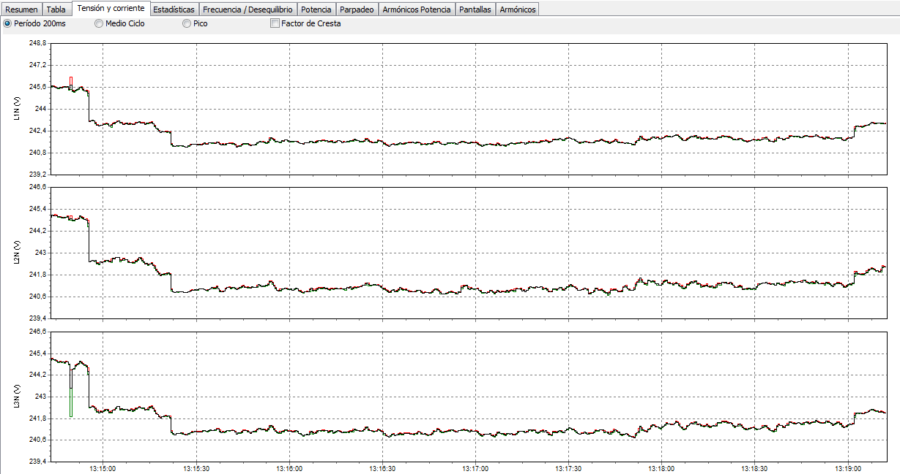

Figure 19: RMS Values of Line Voltages (L-N), Fluke 435



Figure 20: RMS Values of Line Currents, ScopeCorder

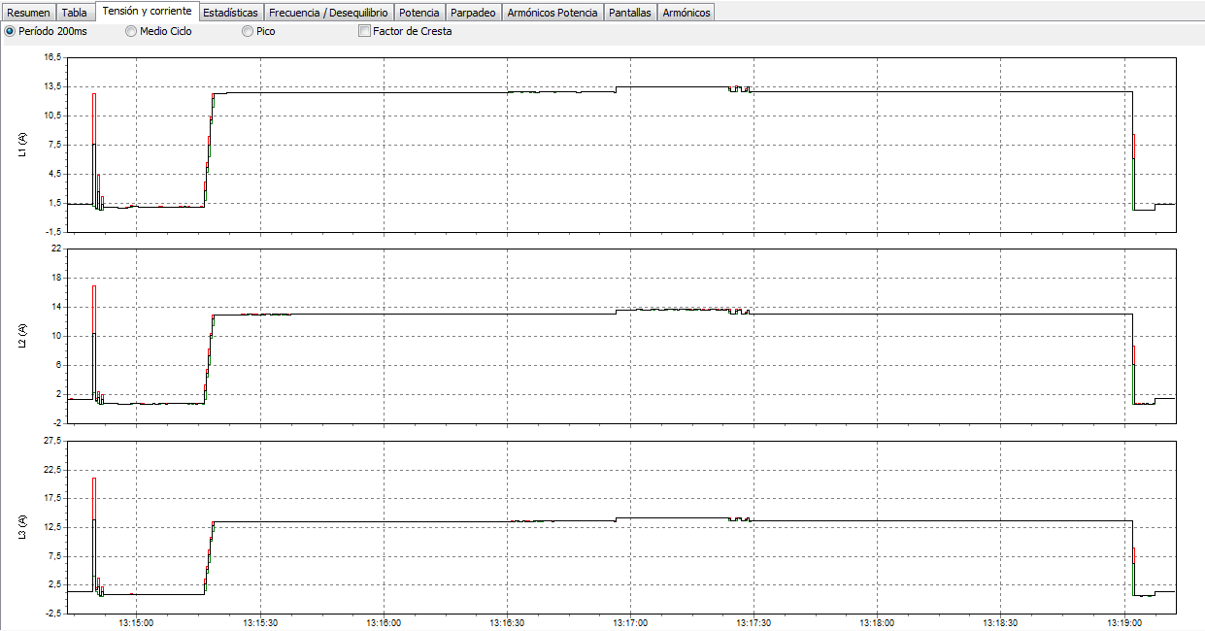

Figure 21: RMS Values of Line Currents, Fluke 435



Figure 22: Voltage and Current Harmonics on L1 (only during Charging Process), ScopeCorder

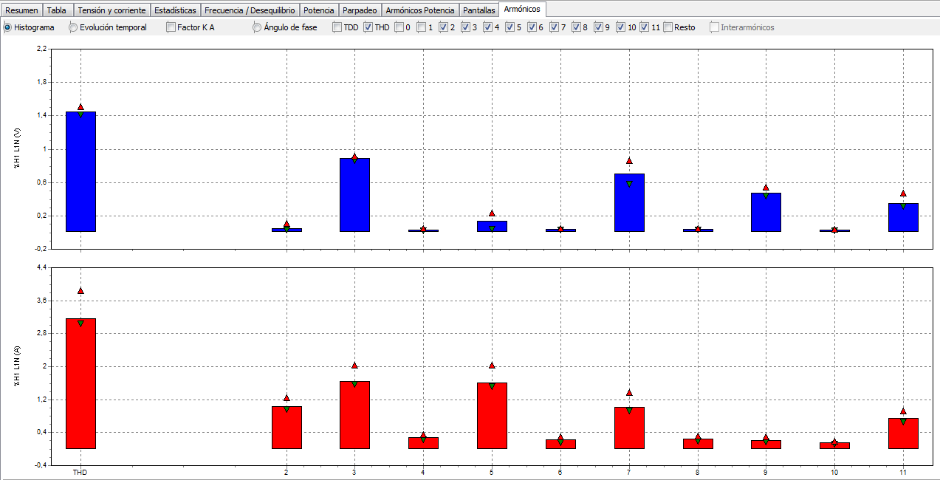

Figure 23: Voltage and Current Harmonics on L1 (only during Charging Process), Fluke 435

The two measurements at the time instant 13:16:00 (13:15:40 at Fluke 435 clock) are compared in the next tables:

|  |  |  |  |  |  |  |  |  |  |  |  |  |  |  |  |  |  |  |  |  |  |  |  |  |  |  |  |  |  |  |  |  |  |  |  |  |  |  |  |  |  |
| --- | --- | --- | --- | --- | --- | --- | --- | --- | --- | --- | --- | --- | --- | --- | --- | --- | --- | --- | --- | --- | --- | --- | --- | --- | --- | --- | --- | --- | --- | --- | --- | --- | --- | --- | --- | --- | --- | --- | --- | --- | --- |
| |  |  |  |  |  | | --- | --- | --- | --- | --- | |  | Scope  Corder | Fluke | Absolute Error | Relative Error | | VL1N | 239,3V | 241,7V | -2,4V | -1,0% | | VL2N | 239,4V | 241,0V | -1,6V | -0,7% | | VL3N | 239,7V | 241,0V | -1,3V | -0,5% | | |  |  |  |  |  | | --- | --- | --- | --- | --- | |  | Scope  Corder | Fluke | Absolute Error | Relative Error | | IL1 | 13,01A | 12,93A | 0,08A | 0,6% | | IL2 | 12,71A | 13,03A | -0,32A | -2,5% | | IL3 | 13,39A | 13,57A | -0,18A | -1,3% | |

Table 7: Voltages and Currents compared at 13:16:00

|  |  |  |  |  |  |  |  |  |  |  |  |  |  |  |  |  |  |  |  |  |  |  |  |  |  |  |  |  |  |  |  |  |  |  |  |  |  |  |  |  |  |  |  |  |  |  |  |  |  |  |  |
| --- | --- | --- | --- | --- | --- | --- | --- | --- | --- | --- | --- | --- | --- | --- | --- | --- | --- | --- | --- | --- | --- | --- | --- | --- | --- | --- | --- | --- | --- | --- | --- | --- | --- | --- | --- | --- | --- | --- | --- | --- | --- | --- | --- | --- | --- | --- | --- | --- | --- | --- | --- |
| |  |  |  |  |  | | --- | --- | --- | --- | --- | |  | Scope  Corder | Fluke | Absolute Error | Relative Error | | PL1 | 3112W | 3120W | -8W | -0,3% | | PL2 | 3006W | 3105W | -99W | -3,2% | | PL3 | 3205W | 3261W | -56W | -1,7% | | Ptot | 9323W | 9485W | -162W | -1,7% | | |  |  |  |  |  | | --- | --- | --- | --- | --- | |  | Scope  Corder | Fluke | Absolute Error | Relative Error | | QL1 | 181var | -135var | 316var | 234,1% | | QL2 | -451var | -464var | 13var | -2,8% | | QL3 | -214var | -229var | 15var | -6,6% | | Qtot | -485var | -829var | 344var | -41,5% | |

Table 8: Active and Reactive Powers compared at 13:16:00

|  |  |  |  |  |  |  |  |  |  |  |  |  |  |  |  |  |  |  |  |  |  |  |  |  |  |  |  |  |  |  |  |  |  |  |  |  |  |  |  |  |  |
| --- | --- | --- | --- | --- | --- | --- | --- | --- | --- | --- | --- | --- | --- | --- | --- | --- | --- | --- | --- | --- | --- | --- | --- | --- | --- | --- | --- | --- | --- | --- | --- | --- | --- | --- | --- | --- | --- | --- | --- | --- | --- |
| |  |  |  |  |  | | --- | --- | --- | --- | --- | |  | Scope  Corder | Fluke | Absolute Error | Relative Error | | THDuL1 | 1,72% | 1,45% | 0,27% | 18,6% | | THDuL2 | 1,23% | 1,50% | -0,27% | -18,0% | | THDuL3 | 1,35% | 1,32% | 0,03% | 2,3% | | |  |  |  |  |  | | --- | --- | --- | --- | --- | |  | Scope  Corder | Fluke | Absolute Error | Relative Error | | THDiL1 | 2,97% | 3,19% | -0,22% | -6,9% | | THDiL2 | 2,98% | 3,31% | -0,33% | -10,0% | | THDiL3 | 2,52% | 2,50% | 0,02% | 0,8% | |

Table 9: Voltage and Current THD compared at 13:16:00

**L1:**

|  |  |  |  |  |  |  |  |  |  |  |  |  |  |  |  |  |  |  |  |  |  |  |  |  |  |  |  |  |  |  |  |  |  |  |  |  |  |  |  |  |  |  |  |  |  |  |  |  |  |  |  |  |  |  |  |  |  |  |  |  |  |  |  |  |  |  |  |  |  |  |  |  |  |  |  |  |  |  |  |  |  |  |  |  |  |  |  |  |  |  |  |  |  |  |  |  |  |  |  |  |  |  |  |  |  |  |  |  |  |  |  |
| --- | --- | --- | --- | --- | --- | --- | --- | --- | --- | --- | --- | --- | --- | --- | --- | --- | --- | --- | --- | --- | --- | --- | --- | --- | --- | --- | --- | --- | --- | --- | --- | --- | --- | --- | --- | --- | --- | --- | --- | --- | --- | --- | --- | --- | --- | --- | --- | --- | --- | --- | --- | --- | --- | --- | --- | --- | --- | --- | --- | --- | --- | --- | --- | --- | --- | --- | --- | --- | --- | --- | --- | --- | --- | --- | --- | --- | --- | --- | --- | --- | --- | --- | --- | --- | --- | --- | --- | --- | --- | --- | --- | --- | --- | --- | --- | --- | --- | --- | --- | --- | --- | --- | --- | --- | --- | --- | --- | --- | --- | --- | --- |
| |  |  |  |  |  | | --- | --- | --- | --- | --- | |  | Scope  Corder | Fluke | Absolute Error | Relative Error | | HARMu2 | 0,16% | 0,05% | 0,11% | 212,7% | | HARMu3 | 0,70% | 0,88% | -0,18% | -20,4% | | HARMu4 | 0,10% | 0,03% | 0,07% | 222,2% | | HARMu5 | 0,20% | 0,20% | 0,00% | 1,0% | | HARMu6 | 0,74% | 0,05% | 0,69% | 1373,3% | | HARMu7 | 0,72% | 0,69% | 0,03% | 5,0% | | HARMu8 | 0,05% | 0,03% | 0,02% | 80,1% | | HARMu9 | 0,58% | 0,45% | 0,13% | 29,9% | | HARMu10 | 0,04% | 0,02% | 0,02% | 114,6% | | HARMu11 | 0,32% | 0,29% | 0,03% | 11,8% | | |  |  |  |  |  | | --- | --- | --- | --- | --- | |  | Scope  Corder | Fluke | Absolute Error | Relative Error | | HARMi2 | 0,77% | 1,03% | -0,26% | -24,9% | | HARMi3 | 1,66% | 1,70% | -0,04% | -2,4% | | HARMi4 | 0,15% | 0,28% | -0,13% | -47,8% | | HARMi5 | 1,52% | 1,59% | -0,07% | -4,7% | | HARMi6 | 0,09% | 0,20% | -0,11% | -55,5% | | HARMi7 | 1,03% | 1,09% | -0,06% | -5,8% | | HARMi8 | 0,20% | 0,21% | -0,01% | -5,7% | | HARM9 | 0,13% | 0,23% | -0,10% | -43,2% | | HARMi10 | 0,08% | 0,13% | -0,05% | -35,1% | | HARMi11 | 0,66% | 0,77% | -0,11% | -13,8% | |

Table 10: Voltage and Current Harmonics on L1 compared at 13:16:00

**L2:**

|  |  |  |  |  |  |  |  |  |  |  |  |  |  |  |  |  |  |  |  |  |  |  |  |  |  |  |  |  |  |  |  |  |  |  |  |  |  |  |  |  |  |  |  |  |  |  |  |  |  |  |  |  |  |  |  |  |  |  |  |  |  |  |  |  |  |  |  |  |  |  |  |  |  |  |  |  |  |  |  |  |  |  |  |  |  |  |  |  |  |  |  |  |  |  |  |  |  |  |  |  |  |  |  |  |  |  |  |  |  |  |  |
| --- | --- | --- | --- | --- | --- | --- | --- | --- | --- | --- | --- | --- | --- | --- | --- | --- | --- | --- | --- | --- | --- | --- | --- | --- | --- | --- | --- | --- | --- | --- | --- | --- | --- | --- | --- | --- | --- | --- | --- | --- | --- | --- | --- | --- | --- | --- | --- | --- | --- | --- | --- | --- | --- | --- | --- | --- | --- | --- | --- | --- | --- | --- | --- | --- | --- | --- | --- | --- | --- | --- | --- | --- | --- | --- | --- | --- | --- | --- | --- | --- | --- | --- | --- | --- | --- | --- | --- | --- | --- | --- | --- | --- | --- | --- | --- | --- | --- | --- | --- | --- | --- | --- | --- | --- | --- | --- | --- | --- | --- | --- | --- |
| |  |  |  |  |  | | --- | --- | --- | --- | --- | |  | Scope  Corder | Fluke | Absolute Error | Relative Error | | HARMu2 | 0,10% | 0,05% | 0,05% | 100,1% | | HARMu3 | 0,64% | 1,03% | -0,39% | -37,6% | | HARMu4 | 0,07% | 0,06% | 0,01% | 21,3% | | HARMu5 | 0,29% | 0,21% | 0,08% | 35,8% | | HARMu6 | 0,02% | 0,03% | -0,01% | -18,1% | | HARMu7 | 0,69% | 0,69% | 0,00% | -0,4% | | HARMu8 | 0,04% | 0,03% | 0,01% | 36,2% | | HARMu9 | 0,41% | 0,45% | -0,04% | -7,9% | | HARMu10 | 0,03% | 0,02% | 0,01% | 42,7% | | HARMu11 | 0,25% | 0,29% | -0,04% | -13,7% | | |  |  |  |  |  | | --- | --- | --- | --- | --- | |  | Scope  Corder | Fluke | Absolute Error | Relative Error | | HARMi2 | 0,68% | 0,65% | 0,03% | 3,9% | | HARMi3 | 1,68% | 2,03% | -0,35% | -17,0% | | HARMi4 | 0,23% | 0,14% | 0,09% | 62,1% | | HARMi5 | 1,96% | 1,99% | -0,03% | -1,8% | | HARMi6 | 0,05% | 0,16% | -0,11% | -68,8% | | HARMi7 | 0,59% | 0,79% | -0,20% | -25,9% | | HARMi8 | 0,08% | 0,22% | -0,14% | -61,7% | | HARM9 | 0,34% | 0,35% | -0,01% | -3,8% | | HARMi10 | 0,18% | 0,22% | -0,04% | -16,8% | | HARMi11 | 0,29% | 0,44% | -0,15% | -35,2% | |

Table 11: Voltage and Current Harmonics on L2 compared at 13:16:00

**L3:**

|  |  |  |  |  |  |  |  |  |  |  |  |  |  |  |  |  |  |  |  |  |  |  |  |  |  |  |  |  |  |  |  |  |  |  |  |  |  |  |  |  |  |  |  |  |  |  |  |  |  |  |  |  |  |  |  |  |  |  |  |  |  |  |  |  |  |  |  |  |  |  |  |  |  |  |  |  |  |  |  |  |  |  |  |  |  |  |  |  |  |  |  |  |  |  |  |  |  |  |  |  |  |  |  |  |  |  |  |  |  |  |  |
| --- | --- | --- | --- | --- | --- | --- | --- | --- | --- | --- | --- | --- | --- | --- | --- | --- | --- | --- | --- | --- | --- | --- | --- | --- | --- | --- | --- | --- | --- | --- | --- | --- | --- | --- | --- | --- | --- | --- | --- | --- | --- | --- | --- | --- | --- | --- | --- | --- | --- | --- | --- | --- | --- | --- | --- | --- | --- | --- | --- | --- | --- | --- | --- | --- | --- | --- | --- | --- | --- | --- | --- | --- | --- | --- | --- | --- | --- | --- | --- | --- | --- | --- | --- | --- | --- | --- | --- | --- | --- | --- | --- | --- | --- | --- | --- | --- | --- | --- | --- | --- | --- | --- | --- | --- | --- | --- | --- | --- | --- | --- | --- |
| |  |  |  |  |  | | --- | --- | --- | --- | --- | |  | Scope  Corder | Fluke | Absolute Error | Relative Error | | HARMu2 | 0,15% | 0,06% | 0,09% | 147,4% | | HARMu3 | 0,97% | 0,94% | 0,03% | 3,7% | | HARMu4 | 0,03% | 0,02% | 0,01% | 63,3% | | HARMu5 | 0,35% | 0,37% | -0,02% | -4,5% | | HARMu6 | 0,06% | 0,05% | 0,01% | 11,0% | | HARMu7 | 0,54% | 0,52% | 0,02% | 2,9% | | HARMu8 | 0,04% | 0,03% | 0,01% | 43,7% | | HARMu9 | 0,39% | 0,35% | 0,04% | 12,4% | | HARMu10 | 0,04% | 0,03% | 0,01% | 29,3% | | HARMu11 | 0,19% | 0,18% | 0,01% | 5,2% | | |  |  |  |  |  | | --- | --- | --- | --- | --- | |  | Scope  Corder | Fluke | Absolute Error | Relative Error | | HARMi2 | 0,70% | 0,39% | 0,31% | 78,6% | | HARMi3 | 0,72% | 0,66% | 0,06% | 8,9% | | HARMi4 | 0,41% | 0,19% | 0,22% | 117,8% | | HARMi5 | 1,93% | 1,94% | -0,01% | -0,5% | | HARMi6 | 0,07% | 0,24% | -0,17% | -70,5% | | HARMi7 | 0,36% | 0,58% | -0,22% | -37,6% | | HARMi8 | 0,16% | 0,22% | -0,06% | -25,6% | | HARM9 | 0,14% | 0,27% | -0,13% | -49,7% | | HARMi10 | 0,07% | 0,19% | -0,12% | -65,0% | | HARMi11 | 0,32% | 0,59% | -0,27% | -45,2% | |

Table 12: Voltage and Current Harmonics on L3 compared at 13:16:00

## Summary

In general the power analysis with the Yokogawa DL750 ScopeCorder and Matlab post process gives good results. The voltage measurements are slightly lower (≈1%) and the currents differ slightly from the Fluke measurement as well (≈2,5% max), but this might come from the intrinsic error of the current clamps (2%+50mV). In the end, the total active power is 1,7% lower than the Fluke measurement.

However, the reactive power measurement should be seen with caution. L2 and L3 show high coincidence with the Fluke measurement, the reactive power in L1 however is about 300var higher and has another polarity.

The harmonic analysis however is reasonable. The absolute differences of the THD values between the two measurements are between 0,02 and 0,33%. The single current harmonics generally differ around 0,1-0,3% (absolute values) and the voltage harmonics around 0,01%-0,2%. Only two values seem to differ more (6th harmonic on L1 and 3rd harmonic on L2). The voltage harmonics on L3 are the most precise ones. As VL3N was the only line voltage measured with the voltage probe Pico TA057, it is recommended to use these voltage probes for future measurements. Moreover, the rms value of the voltage measured with this probe is closer to the Fluke value than the ones measured with the Yokogawa 700924 voltage probe.

# Appendix

## Formulas for Calculations

***Explanations***

uLi(t) instantaneous AC voltage between line i and N

iLi(t) instantaneous AC current in line i, direction into the charger (or other device to be measured)

uDC(t) instantaneous DC voltage

iDC(t) instantaneous DC current, direction into the EV (or away from the device to be measured)

t0 start time

tn end time

ULi,h(t) RMS value of harmonic of order h of AC voltage between line i and N (from harm50 function)

ILi,h(t) RMS value of harmonic of order h of AC current in line i (from harm50 function)

***Formulas***

$${Urms}_{Li}= \sqrt{\frac{1}{t_{n}-t_{0}}\int_{t_{0}}^{t_{n}}{{u_{Li}(t)}^{2}dt}}$$

$${Irms}_{Li}= \sqrt{\frac{1}{t_{n}-t_{0}}\int_{t_{0}}^{t_{n}}{{i_{Li}(t)}^{2}dt}}$$

$$P_{Li}= \frac{1}{t_{n}-t_{0}}\int_{t_{0}}^{t_{n}}{u_{Li}(t)*i_{Li}(t)dt}$$

$$S_{Li}={Urms}_{Li}*{Irms}_{Li}$$

$$S_{1, Li}={Urms}_{Li}*I_{Li,1}$$

$$Q_{Li}= \sqrt{{S_{Li}}^{2}-{P_{Li}}^{2}} \left(polarity determined by angle between fundamental current and voltage\right)$$

$$Q_{1,Li}= \sqrt{{S_{1,Li}}^{2}-{P_{Li}}^{2}} (polarity determined like Q_{Li})$$

$$P_{AC}= P_{L1}+P_{L2}+P_{L3}$$

$$S= S_{L1}+S_{L2}+S_{L3}$$

$$S_{1}= S_{1,L1}+S_{1,L2}+S_{1,L3}$$

$$Q= Q_{L1}+Q_{L2}+Q_{L3}$$

$$Q_{1}= Q_{1,L1}+Q_{1,L2}+Q_{1,L3}$$

$$power factor PF= \left|\frac{P_{AC}}{S}\right|$$

$$cos⁡(φ)= \left|\frac{P_{AC}}{S_{1}}\right|$$

$${THDu}_{Li}= \sqrt{\sum_{h=2}^{50}{{\left(\frac{U_{Li,h}}{U_{Li,1}}\right)}^{2}}}$$

$${THDi}_{Li}= \sqrt{\sum_{h=2}^{50}{{\left(\frac{I_{Li,h}}{I_{Li,1}}\right)}^{2}}}$$

$$U_{DC }=\frac{1}{t_{n}-t_{0}}*\int_{t_{0}}^{t_{n}}{u_{DC}(t)dt}$$

$$I_{DC }=\frac{1}{t_{n}-t_{0}}*\int_{t_{0}}^{t_{n}}{i_{DC}(t)dt}$$

$$P_{DC}= \frac{1}{t_{n}-t_{0}}\int_{t_{0}}^{t_{n}}{u_{DC}(t)*i_{DC}(t)dt}$$

$$ripple factor r_{uDC}=\max\left(u_{DC}\left(t\right)\right)-\min\left(u_{DC}\left(t\right)\right)$$

$$ripple factor r_{iDC}=\max\left(i_{DC}\left(t\right)\right)-\min\left(i_{DC}\left(t\right)\right)$$

$$efficiency η=\frac{P_{DC}}{P_{AC}}*100 \left(if>100, η=\frac{P_{AC}}{P_{DC}}*100\right)$$

$$P_{losses}=\left|P_{AC}-P_{DC}\right|$$

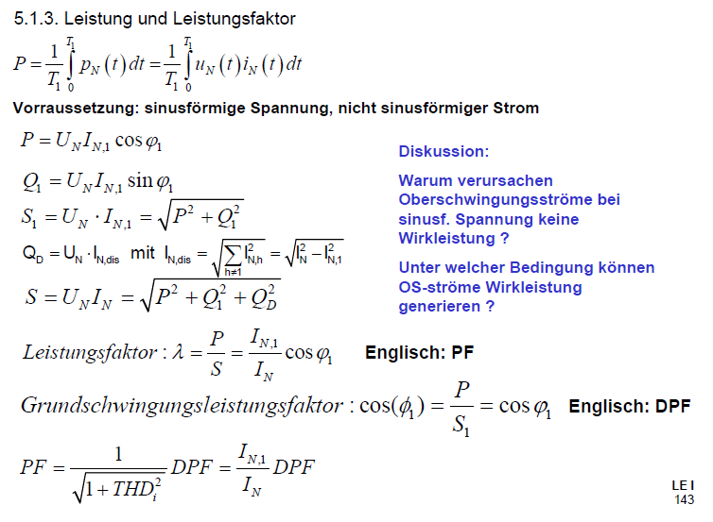

Figure 24: Formulas based on Power Electronics Script by Prof. Bernet, TU Dresden